Software Engineering

Lab Activity: Set up a database in JavaDB for a Java application

1. Activity Brief

This activity will introduce the set up of JavaDB in Netbeans.

  - Set up of JavaDB

Open the JavaApplication1project and the Person.java file. Modify the Person.java file as below:

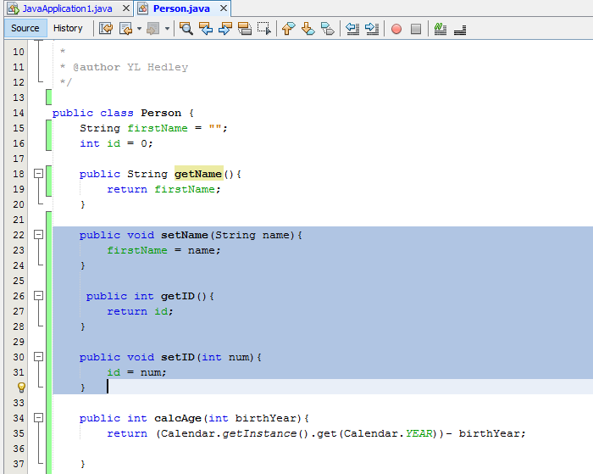
Update the Person file with the additional code highlighted.

Follow the steps to set up JavaDB in Netbeans:

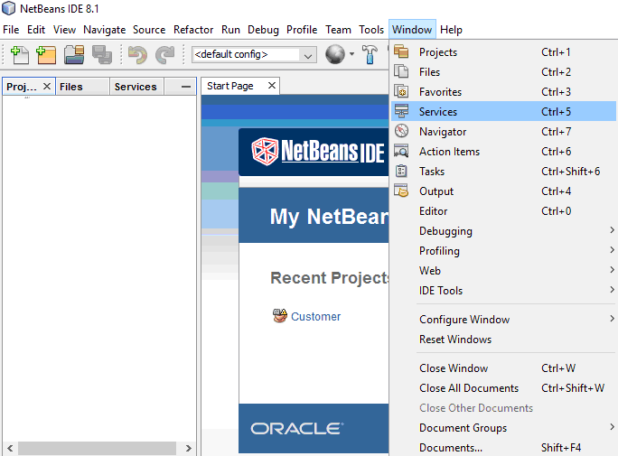

Open Netbeans, go to Window and click on Services.

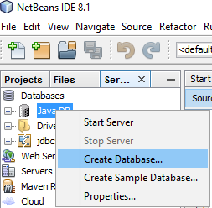
Go to the Services tab. Right click on JavaDB and select Create Database…

Enter details in the Database Name, User Name, Password, Confirm Password fields.

A database link will be created.

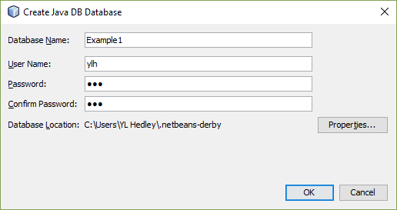

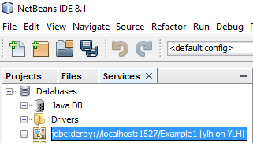

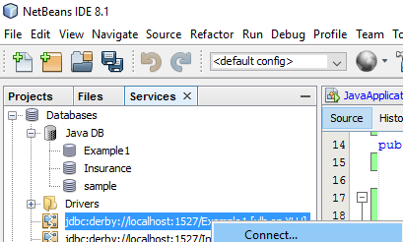

Right click on the database link and select Connect…

Right click on Tables and select Create Table...

Enter Person in the Table name field.

Click on Add column to create a column.
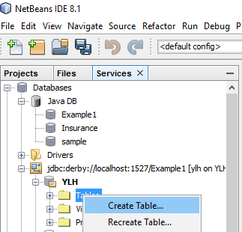

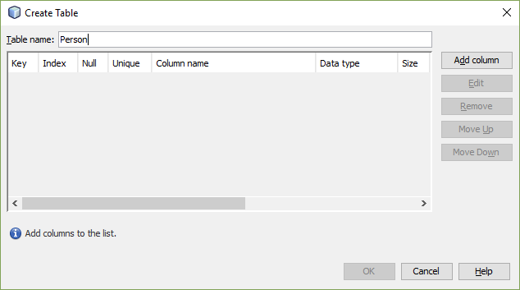

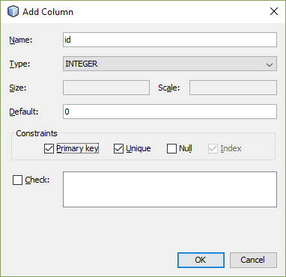
To add a column, enter the details in the fields as shown here.

id: INTEGER, default: 0, Primary key
firstname: VARCHAR, default: “”, size: 10

Click on OK when completed.

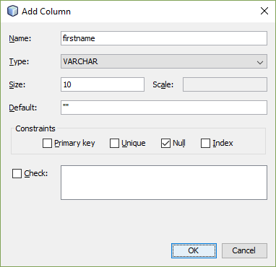

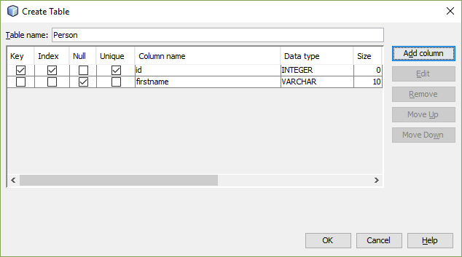

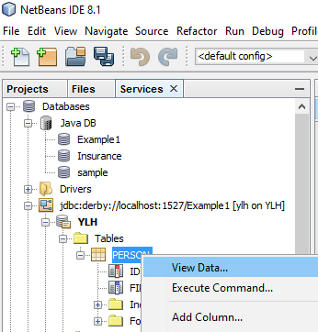

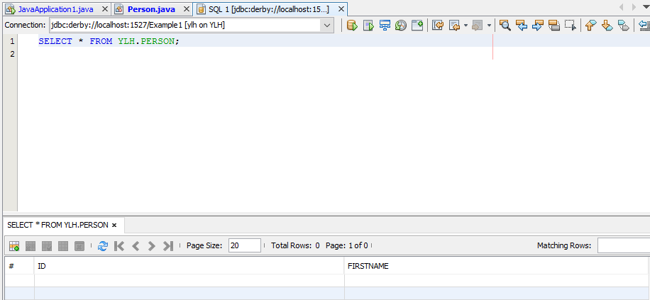
Expand Tables to see the Person Table.

Right click on Person, select View Data…
A blank table with field names is displayed.

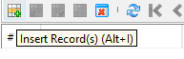

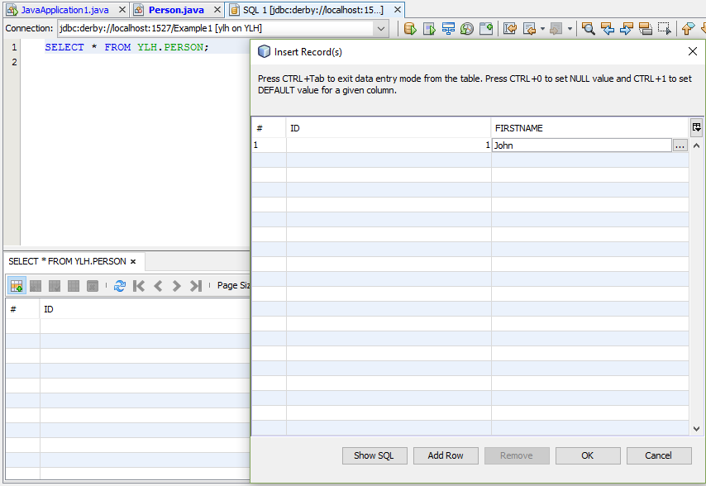
Click on the ‘Insert Record(s) to display the dialogue box.

Enter one sample record as below:
id: 1; firstname: John

The record is shown here.

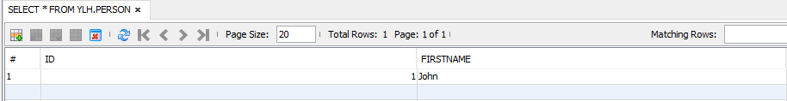

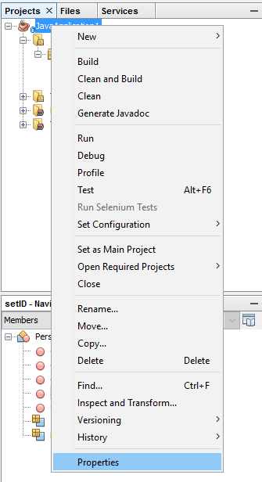
Go to the Projects tab. Right click on your project, JavaApplication1, and select Properties.

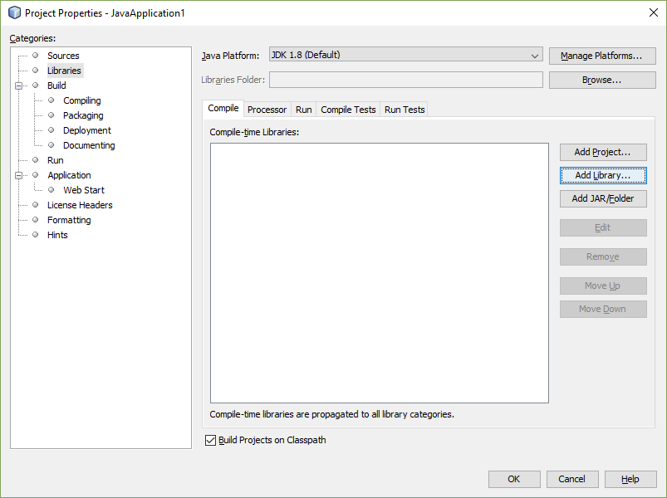
Click on Library and Add Library…

Select Java DB Driver and click on Add Library…

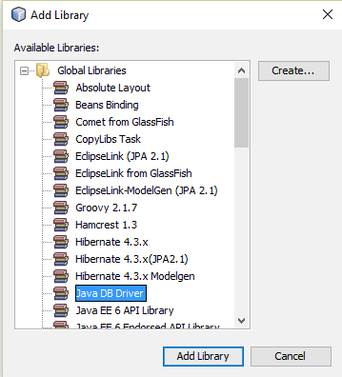

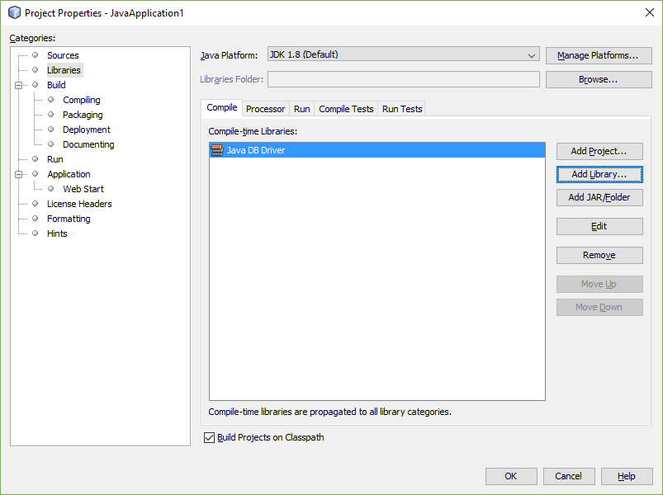
Java DB Driver is now added to the library.

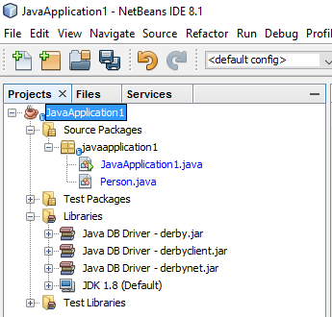

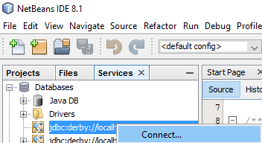

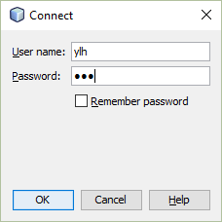
Before running a java program, you need to make sure the following:

The database link is connected. Enter User name and Password to connect to the database if requested.

JavaDB and Start Server… to start the server.

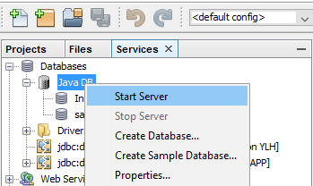

Go to the Projects tab, double click on LayeredExample.jave file to open it, if it is not open.

Enter the code here to the start of your class.

Copy and paste the code shown here to the ‘JavaApplication1’ file, after the line below:

public static void main(String[] args) {

Import java.sql.*;
public class JavaApplication1 {

/**
* @param args the command line arguments
*/
public static void main(String[] args) {

//sample code to demo the databaase connection and sql statements
String connectionURL = "jdbc:derby://localhost:1527/Example1";
String uName = "ylh";
String uPass= "ylh";

//ConnectionURL, username and password should be specified in getConnection()
try {
Connection conn = DriverManager.getConnection(connectionURL, uName, uPass);
System.out.println("Connect to database...");

if (conn != null){
Statement st = conn.createStatement();
ResultSet rs=null;

//retrieve the sample records
System.out.println("retrieve the sample records");
System.out.println("---------------------------------");
String sql = "SELECT * FROM Person";
rs=st.executeQuery(sql);
while(rs.next()){
System.out.println(rs.getInt("id")+"\t"+rs.getString("firstname"));
}

//insert a new record
sql = "INSERT INTO Person VALUES (2, 'Paul')";
st.executeUpdate(sql);

System.out.println("insert a sample record");
System.out.println("---------------------------------");
sql = "SELECT * FROM Person ";
rs=st.executeQuery(sql);
while(rs.next()){
System.out.println(rs.getInt("id")+"\t"+rs.getString("firstname"));
}

//update a record
sql = "UPDATE Person SET firstname='David' WHERE id=1";
st.executeUpdate(sql);

System.out.println("update the sample record");
System.out.println("---------------------------------");
sql = "SELECT * FROM Person ";
rs=st.executeQuery(sql);
while(rs.next()){
System.out.println(rs.getInt("id")+"\t"+rs.getString("firstname"));
}

//delete a record
sql = "DELETE FROM Person WHERE ID=1";
st.executeUpdate(sql);

System.out.println("delete the sample record");
System.out.println("---------------------------------");
sql = "SELECT * FROM Person ";
rs=st.executeQuery(sql);
while(rs.next()){
System.out.println(rs.getInt("id")+"\t"+rs.getString("firstname"));
}
rs.close();
st.close();
conn.close();
System.out.println("Connection is closed.");

} else {
System.out.println("null");
}

} catch (SQLException ex) {
System.out.println("SQLException error");
}
}
}

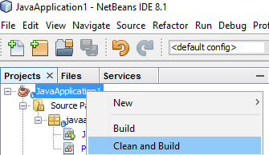

Right click on JavaApplication1.java and select Clean and Build to compile it.

After successfully compiled, right click on JavaApplication1.java and select Run File to run it.

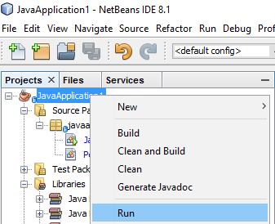

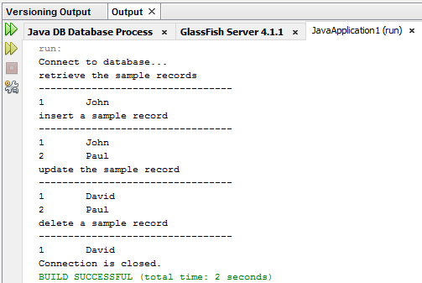
In the Output window, the results are displayed.

